Handling technique development of live carp, Cyprinus Carpio, in cold dry styrofoam box
I Ketut Suwetja¹, Netty Salindeho¹, I Gede Prabawa Suwetja²
¹ Departement of Fisheries Technology, Faculty of Fisheries and Marine Science, Sam Ratulangi University, Manado 95115, Indonesia
²Departement of Accounting, Faculty of Economic and Business, Sam Ratulangi University, Manado, 95115, Indonesia

suwetja.i.k@gmail.com

Abstract. The study focused on several following aspects: temperature and time optimation for fainting, holding media optimation, temperature and time optimation for recovery, and their correlation with mortality rate of carp, Cyprinus carpio. Fainting occurred at the optimum time of 11 minutes and 03 seconds, temperature of 8⁰C, and holding time of 6 hours. Holding medium was rice husk. The fastest consciousness of the fish was found in 6 volt-aerated water medium. The fish consciousness after 6 hours of storing in the rice husk at the fainting temperature of 8⁰C was found faster (p < 0.05), 11 minutes and 15 seconds, than that added with 0.02% of clove oil, 25 minutes and 16 seconds. The fish mortality rate after 6 hours of storage in the rice husk at fainting temperature of 8⁰C was lower (p < 0.05), 46%, than that with addition of 0.02% of clove oil, 75%.
1. Introduction
Live fish transportation in Indonesia is generally conducted using a water-containing plastic bag filled with either oxygen addition or not, depending upon its necessity. Such a packing and transporting technique has some weaknesses, such as less efficient in weight, volume, and transport cost, decreasing water oxygen content, increased water temperature, fish poisoning from their feces, and relatively long transportation.
Nowadays, live fish transportation has been developed using a dry medium through low temperature fainting method. It is done by cooling the water down to the fainting temperature of the fish. Low temperature is maintained in the Styrofoam box by placing some ice cube. Cool media for fish storage use either rice husk or sawdust.
One of the main goals in live fish transportation is to yield low mortality rate, and therefore, the fish must be fainted. Immotilization is necessarily done that the fish metabolism activity is in basal condition. At very low respiration and metabolism rate, the fish can be transported in long duration at low mortality rate. There are several immotilization techniques, such as the use of low temperature or the use of natural or artificial anti-metabolite (Wijayanti et al., 2011 ).
Before storing, the fish is previously wrapped with paper to avoid the fish mouth filled with the media material (Suwetja et al., 1993). The wrapped fish is then placed and set in the styrofoam containing cool sawdust of 10-15°C. The fish placement is done in layers, media-fish-media etc., and the top layer is media. The media thickness is more or less 2-3 cm. To maintain the temperature stability, the Styrofoam is filled some ice cube (Suwetja and Pongoh, 2000).
Re-awaking carp after fainted and stored can be done by returning the fish into a sufficiently aerated tank at their habitat temperature, 25-27°C. The survival of live fish packed in unconscious condition is affected by initial condition of the fish, fainting temperature, fish origin, and shocks from overlapping at the lower level that causes fish mortality during the transportation (Hjeltnes et al., 2008; Suwetja et al., 2012).
Rinto (2012), Miranti (2011), Junianto (2003), Amend et al., (1982), Berka (1986), and Gomes et al. (2003) also supported that live fish transportation was basically aimed to maintain the fish survival during the transportation reaching the target location. Close distance transportation does not need specific treatment, but long distance transportation requires particular treatments to maintain the fish survivorship. Therefore, an appropriate live fish transportation technology following the commodity and condition requirements is needed. Basically, there are two live fish transportation methods, the use of water as media called wet system and the use of dry system (media without water).
The principle of live fish handling is maintaining the fish survivorship as maximum as possible up to accepted by the consumer. For this, there are several handling phases, pre-transport, transport, and post-transport handlings. Closed transportation will yield CO₂ accumulation and pH decline (Grottum et al., 1997; King, 2009; Farrell et al., 2010).
2. Material and Methods
Fainting media used low temperature of 8°C and low temperature of 8ºC added with 0.02% of clove oil. Storing media employed rice husk. Sawdust was not used as storing media because it has hazardous material for fish. The ice cube placed in a storing box was 1.8 kg. The fish were held for 8 hours and observed every 2 hours. Holding time treatments were 0, 2, 4, 6, and 8 hours with 2 replications. Parameters recorded were fainting rate time (Septiarusli et al., 2012, and Suwetja, et al., 2016), reawaking time (Anggriani et al., 2014, and Suwetja., et al., 2016), and fish mortality (Jailani, 2000, and Suwetja, et al., 2016).
3. Statistical Analysis
This study used Factorial Complete Randomized Design with two factors as follows:
- Fainting method (A) with two levels: A1 – fainting at 8ºC and A2 – fainting at 8ºC plus 0.02% of clove oil
- Storage duration (B ) with five levels: B1: 0 hours, B2- 2 hours, B3- 4 hours, B4- 6 hours, and B5- 8 hours.
4. Results and Discussion
Fainting Speed Time of C. carpio
Mean value of fainting speed time ranged from 1.2 to 14.16 minutes (Fig. 1).
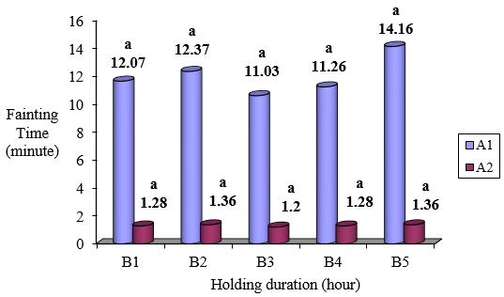
Figure 1. Fainting method and storage duration with fainting speed of C. carpio. A1: temperature of 8°C, A2 : temperature of 8°C + 0.02% of clove oil. B1 : 0 hour, B2 : 2 hours, B3 : 4 hours, B4 : 6 hours, B5 : 8 hous.
ANOVA showed that fainting method treatment, storing time, and their interaction did not significantly influence the fainting speed time (P > 0.05). Faster fainting time occurred in the method using clove oil since addition of clove oil into water media caused the dissolved oxygen in the water be reducing. Clove oil could function as insulator or barrier for oxygen diffusion process into the water. According to Ferdiansyah (2000), dissolved oxygen decline is directly proportional to the increase in clove oil concentration, since oxygen diffusion process into the water is inhibited. The higher the clove oil concentration is, the lower the oxygen diffusion into the water will be. Eugenol as water-soluble anesthetic will reduce respiration rate of the fish. Decline in the respiration rate results in loss of all feelings on the fish body due to reduced nerve function so that nerve impulse action and delivery are inhibited (Saskia et al., 2012). According to Smith and Breet in Wilford (1970), the ionic balance disturbance in fish brain causes the gill unable to normally function, and the osmoregulation of dissolved oxygen in the water into blood cells and gill be disturbed.
Statistical analysis found that the treatment of holding duration did not give significant effect on the fainting speed time of the carp. It could result from that holding duration treatment was done after the fainting process ended so that it did not affect the fainting time.

Re-awaking Time of C. carpio
Mean value of re-awaking time of C. carpio ranged from 0.3 – 25.16 minutes. ANOVA indicated that at the confidence level of 95% fainting method, holding duration, and the treatment interaction gave significant effect on the re-awaking timeof C. carpio (P< 0.05).

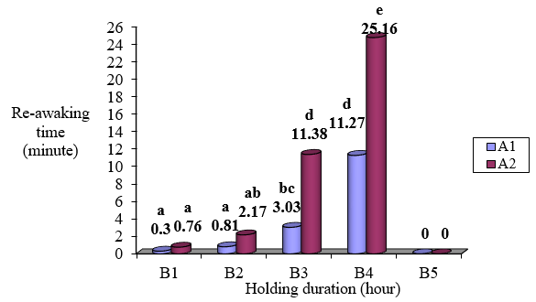
Figure 2. Fainting method and holding duration relationship with re-awaking time of C. carpio. A1: temperature of 8°C, A2 : temperature of 8°C added with clove oil of 0.02%; B1: 0 hour, B2: 2 hours, B3: 4 hours, B4: 6 hours, B5: 8 hours.

LSD test on comparison between treatments against the e-awaking time is presented in Fig. 2. The use of fainting method at 8°C and holding duration of 0 hour (A1B1) showed the fastest recovery time, 0.3 minute and the longest recovery time was recorded in fainting method treatment of 8°C added with clove oil of 0.02% for storing duration of 6 hours (A2B4), 25.16 minutes.
This finding reflects that the use of fainting method added with clove oil of 0.02% for 6 hours of storage results in longer re-awaking time than that a without clove oil addition. It could result from that active compounds in the circulatory system of the fish body at certain amount make the fish need longer time to return to normal condition. Eugenol as active compound in the clove oil is an antiseptic material that can weaken the nerve and disturb the nerve system (Hart, 1990).
Based on re-awaking time data, it is apparent that fainting method of 8°C be an effective method to faint the fish with storage duration up to 6 hours compared with the fainting method using temperature of 8°C with clove oil addition of 0.02%.
Mortality of C. carpio
Mortality rate of C. carpio is presented in Fig. 3. Mean mortality rate ranged from 0 to 100%.

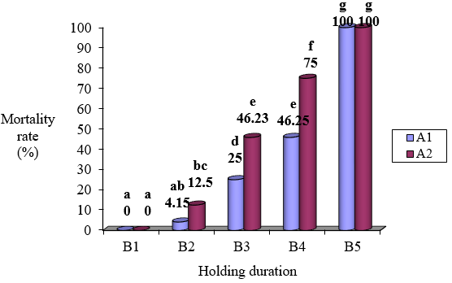
Figure 3. Fainting method and holding time relationship with the mortality rate of C. carpio. A1: temperature of 8°C, A2 : temperature of 8°C + 0.02% of clove oil; B1: 0 hour, B2: 2 hours, B3: 4 hours, B4: 6 hours, B5: 8 hours;

ANOVA indicated that fainting method, storing duration and treatment interaction gave significant effect on the mortality rate of C. carpio (P ≤ 0.05). LSD test reflected that the mortality rate of C. carpio for 6-hour storage using fainting method of 8°C was found lower than that in fainting method of 8°C added with clove oil of 0.02%, 46.25% and 75%, respectively. It means that the use of fainting method of 8°C is better than that of 8°C added with clove oil of 0.02%.
This study also found that the longer the storing duration was, the higher the fish mortality could be. The fish, particularly C. carpio, were only capable of surviving up to 6 hours of storage. All C. carpio died in 8 hours of storage.

5. Conclusion
Optimum fainting time was 11.26 minutes and temperature of 8°C through treatment combination with 6-hour storage. Good holding media was rice husk, because the sawdust, despite implementation of initial washing and re-drying, the effect of wood latex on the mortality is still high. Optimum mortality rate, 46%, was obtained at the holding media of rice husk and 6 hours of storage using fainting method of 8°C without clove oil addition.
Optimum re-awaking time was found at 11.27 minutes through treatment combination of 6-hour holding time and optimum fainting temperature of 8°C. Re-awaking was conducted using 1.5 volt and 3.0 volt aerator, but the fish awake faster at the use of 3.0 volt aerator, since more dissolved oxygen were supplied at the 3.0 volt aerator application than that at 1.5 volt.

References
[1] Amend, D. F., Crov, T.R. & Goven, B. A., Transportation of fish in closed system; methods to control. 1982 ammonia, carbon dioxide, pH and bacterial growth. Trans. Am. Fish .Soc., 111(5):603-ll.
[2] Anggraini, D., Taqwa, F. H, and Yulisman, 2014. Mortality of carp (Cyprinus carpio) at the bagasse thickness substrate and different transport duration. J. Fish. And Mar. (8) : 78-89.
[3] Berka, 1986. The Transport of live fish. A Review. (EIFAC Technical Paper 48). Food and Agriclture Organization Of The United Nations.http://www.fao.org (29 Mei 2010).
[4] Farrell, A., Tang, S., Nomura, M., & Brauner C., 2010. Toward Improved Public Confidence in Farmed Fish: A Canadian Perspective on Fish Welfare during Marine Transport. Journal Of The World Aquaculture Society. 41, 225-239.
[5] Ferdiansah, 2000. Toxicity and anesthetic of clove oil (Eugenol Aromaticum) on catfish (Pengasius hypophthalmus) FPIK IPB.
[6] Gomes, L.C.; Araujo, L. C. A. R. M., & Roubach, R.., 2003. Effect of fish density during transportation on stress and mortality of juvenile tambaqui Colossoma macropomum. J. World Aquac. Soc., v.34, p.76-84, 2003a.
[7] Grottum, J., Staurnes, M., & Sigholt, T., 1997. Effect of oxygenation, aeration and pH control on water quality and survival of turbot, Scophthalmus maximus (L), kept at high densities during transport. Aquaculture Research 28, 159-164.
[8] Hart, H. 1990. Organic Chemistry. Translation. Suminar Erlangga, Jakarta.
[9] Hjeltnes, B., Waagbo, R., Finstad, B., Rosseland, B.O., Rosten, T.R., & Stefansson, S., 2008. Transportation of fish within a closed system. In, p. 63. Norwegian Scientific Committee for Food Safety.
[10] Jailani. 2000. Study on the effect of banana stalk as fill material on the survival rate of carp (Cyprinus carpio) [research paper]. Bogor : Fac. Fish. And Mar. Sci., Institut Pertanian Bogor.
[11] Junianto. 2003. Fish handling techniques. Jakarta: Penebar Swadaya.
[12] King, H., 2009. Fish transport in the aquaculture sector: An overview of the road transport of Atlantic salmon in Tasmania. J. Veterinary Behavior -Clinical Application and Research 4, 163-168.
[13] Miranti. 2011. Study on transportation of carp (Cyprinus carpio) using dry system with Styrofoam media. [PKM-AI]. Bogor: Depart. of Aquaculture. Fac.Fish and Mar. Sci. Institut Pertanian Bogor.
[14] Rinto, 2012. Transportasi ikan hidup. http://teknologipascapanen. blogspot.co.id/2012/02/ transportasi-ikan-hidup.html. Diakses 22 Mei 2017.
[15] Saskia, Y. Haspeni, E. and Tutik, K, 2012. Toxicity and Anesthetic Ability of clove oil (Eugenol Aromaticum) on red rainbowfish (Glassolepis nisicus). J. Fisheries Sci.. and Aquatic Resources.
[16] Septiarusli, I. E., Haetami, K., Mulyani, Y., and Dono, D. 2012. Secondary metabolite potential of futu seed (Baringgtonia asiaica) extract in anesthesis of Tiger grouper (Ephinephelus fuscoguttatus). J. Perikanan dan Ilmu Kelautan Vol. 3(3): 295-299.
[17] Suwetja, I K., A. Agustin, M.Mengga. 1993. Live carp packing experiment without water media. Paper. FPIK UNSRAT.
[18] Suwetja, I K., dan J. Pongoh, 2000. Study on rice husk utilization for live carp transportation in the dry insulated wooden box. Report. UNSRAT.
[19] Suwetja, I K., S. Rogi, and J. Pongoh. 2012. Study on sawdust utilization for live fish transportation in dry media container. Report. UNSRAT.
[20] Suwetja I.K., J. Pongoh & Prabawa I. G., 2015. The use of sawdust for live carp transportation in dry Styrofoam. [Final Repot]. Lembaga Penelitian dan Pengabdian kepada Masyarakat, Universitas Sam Ratulangi Manado.
[21] Suwetja I. K., Salindeho. N., & Suwetja, I. G., 2016. Technical development of live carp in the dry Styrofoam for inter-regency, city, and islandmarketing in order to raise the added economic value. Year-end report on national priority research of Acceleration and Extension Masterplan of Indonesia Economic Development - 2011-2025(Perprinas MP3EI 2011-2025. Universitas Sam Ratulangi.
[22] Wijayanti, I., Tapotabun, E. J., Salim, A., Nuer’aenaj, N., Litaay, C., Putri, R. M. S., Kaya, A. O. W., and Suwandi, R., 2011. The effect of temperature on the anesthetic condition of freshwater pemfret, Colossoma macropomum, and freshwater lobster, Cherax quadricarinatus. Proceeding on Small Islands Development, 2011 - ISBN: 978-602-98439-2-7 : 67-76.
[23] Wilford, W.A, 1970. Effect of MS 222 on electrolyte and water content in the brain in rainbow trout. US Burean of Sport Fisheries and Wildlife Investigation in Fish Control.

