Mix Design Stabilization of Concrete Paving Block (CPB) with Hydraulic Pressing Technology
Erno Widayanto^{1,2},Agoes Soehardjono², Wisnumurti², . Achfas Zacoeb²

¹ Deparment of Civil Engineering, Faculty of Engineering, University of Jember, Jember 68121, Indonesia
² Deparment of Civil Engineering, Faculty of Engineering, University of Brawijaya, Jember 68121, Indonesia

Email : widayanto@ymail.com

Abstract. Concrete Paving Block (CPB) is a building material composition made from a mixture of portland cement, sand / aggregate and water and with or without other additives. As a choice of road construction, other than asphalt road and concrete. Paving is rich in colors and patterns for its applications. CPB deliberately designed with an attractive style to suit the tastes of the market and designed with the power that suits the needs. CPB compaction technology has been done in the community according to its funding capability. The simplest compacting technology to the most modern and expensive is manual compaction technology, vibration blocking technology, hydraulic pressure compaction technology and the most modern technology is vibropressing. The most modern technology certainly produces the best pressure quality. Two manual compaction technologies and vibrating blocks are very difficult to produce high quality while the compacting technology with hydraulic pressing is most likely to reach a quality close to modern technology. Therefore, in the following research is how to get the best CPB quality by using hydraulic pressing compaction technology using some methods. Stabilization of pressing technology on making concrete paving block used is mix design with variation of FAS, mix design with variation of fly ash and mix design with variation of ash content. from testing it was found that FAS above 0.5 has a compressive strength tends to decrease from all test behavior. Medium controlled Fas both fly ash and rock ash content, will tend to have a compressive strength that increases to levels of 20% of cement content. But the pressing technology on CPB making is still difficult to penetrate the strength figure of 300 kg / cm2.

Key words: Concrete Paving Block, a mixture

1. Introduction
Concrete Paving Block (CPB) A mixture of building materials made from a mixture of portland cement, sand / aggregate and water and with or without other additives. As a choice of road construction, other than asphalt road and concrete. Paving is rich in colors and motifs for its applications. CPB deliberately designed with attractive motifs to fit the market taste and designed with the strength that suits the needs. This paving pavement is perfect for: Park, Urban and Urban Roads, Parking Lots, Roads and Alleys. The use of CPB as a building cover material for the last 20 years is increasingly being used. Mass production techniques are getting better, so the production of Concrete Paving Block (CPB) is more easily available and makes the price of paving blocks more affordable by the community. So nowadays paving block usage is increasingly used for covering the surface of the yard and also as a cover material for the road surface.
CPBs can be used anywhere with strengthen baseline soil requirements and in a flat surface for CPB installation. When paving has been installed it will have a strong enough resistance. CPBs can be formed to produce attractive effects either as lanes, terraces or mixed with other paving types to create a unique feature. Paving blocks are an alternative to be more traditional asphalt substitutes or road types than use macadam and looked better than macadam or concrete rebates. Currently paving blocks are even used in heavy load areas, such as parking lots, docks and public roads.
The need for high compressive strength is the absolute nature required by the CPB because as its function is bypassed by repetitive vehicle loads. Be the question why is the high compressive CPB required? This is important for concrete density completely because the air cavity reduces the strength of the concrete. For every 1% of air trapped, compressive strength drops between 5 to 7%. This means that concrete containing 5% air cavity simply because incomplete compaction can lose as much as one third of the strength. The air cavity increases the permeability of the concrete. Which in turn will reduce endurance. If the concrete is not solid and impermeable, it will not be watertight. Concrete needs to be compacted to get rid of trapped air cavities. The difference between air cavities and air bubbles should be recorded at this stage. The incoming air bubbles are relatively small and round, increasing the working ability of the mixture, reducing bleeding, and increasing frost resistance. air trapped on the other hand tends to be irregular in shape and detrimental to mix strength. It is to remove this air that the concrete must be well compacted. (Haseeb Jamal, 2014).
Based on SNI 03-0691-1996 CPB is a building material composition prepared from a mixture of portland cement or similar hydrolysis, water and aggregate materials with or without other materials that do not reduce the quality of concrete bricks.
The classification of paving according to SNI 03-0691-1996, consists of:
Quality concrete brick A is used for road
Quality concrete brick B is used for parking equipment
Quality concrete brick C is used for pedestrians
Quality concrete brick D is used for parks and other uses,

CPB should have a flat surface, no cracks and defects in the corners and ribs are not easily masted with the strength of fingers. The size of concrete brick 60 mm thick with a tolerance of + 8%, with physical properties as in table 1.

Table 1 Physical Properties

Quality | Strength(MPa)
 | Mean | min
A | 40 | 35
B | 20 | 17
C | 15 | 12,5
D | 10 | 8,5
Source : SNI 03-0691-1996 ICS. 91.100.30[6]

According to ACI (2013) compressive strength is the dominant measure of CPB performance in many countries. However, these compressive strength requirements seem to vary between those countries [4]. To facilitate different local conditions such as traffic loads, environmental aspects, weather and others. Table 2 briefly summarizes the differences in the compressive strength requirements of paving blocks in different countries.

Table 2. Strength Requirements of Paving Blocks in Various Countries

Coutry | Compression strength (MPa)
United states | 55
Norway | 54
New Zealand | 40
Japan | 59
Italy | 50
Germany | 60
Denmark | 52
Canada | 50
Belgium | 60
Australia | 43
Hongkong | 45
Source : Annual Transactions of IESL, The Institution of Engineers, Sri Lanka (2013)

Meanwhile, Indian standards for paving blocks suggest using different compressive strengths to meet different road traffic requirements, tabulated in Table 3.

Table 3 Recommended value of paving blocks for categories of traffic different according to Indian Standard (IS 15658: 2006)

Grade Designation of Paving Block | Specifead Compressive Strength of Paving Blocks at 28 Days(N/mm²) | Traffic Category
M-30 | 30 | Non Traffic
M-35 | 35 | Light Traffic
M-40 | 40 | Medium Traffic
M-50 | 50 | Heavy Traffic
M-55 | 55 | Very Heavt Traffic
Sumber : Annual Transactions of IESL, The Institution of Engineers, Sri Lanka (2013) [3]

In general, the quality of paving blocks produced with mechanical equipment has a high quality. The ingredients are mixed in certain comparisons according to designated and planned quality, then molded and compacted by various methods. Once opened from the mold it is stored in a place protected from direct sunlight and excessive wind gusts. In order for the results better be treated like a concrete with regular watering. After reaching the age of 28 days CPB can be tested its quality and ready to be marketed. Each variation is made with several factors of cement water. Treatment is performed by watering the paving surface until the age of 7, 14, and 21 days. From the manufacture of manual paving, the average test is obtained by the water factor of cement 0.40 with the compressive strength of 2,103 Mpa, the water factor of cement 0.45 with the compressive strength, the water factor of 2.589 Mpa cement, 0.50 with the compressive strength 2,939 Mpa, the water factor of cement 0.55 with the press force 3,574 Mpa and cement water factor 0.60 d compressive strength 4,092 Mpa [10]. In the process of making manual paving obtained maximum strength of 3,574 Mpa at fas 0,55. And this quality is still very far from expectations.
Almost for all purposes, concrete with minimal and sufficient cement factor to provide the specific workability required for perfect compaction without excessive compaction work is the best concrete (L.J Murdock and K.M. Brooks, 1979). The compressive strength of the concrete will increase according to the age of the concrete. Comparison of compressive strength of concrete at various age Rules of Reinforced Concrete Indonesia 1971. Type of cement effect on compressive strength of concrete, in accordance with the purpose of its use. The types of cement can be in accordance SK SK S-04-1989-F. The most influential aggregate properties of concrete strength are surface roughness. In the aggregate with a rough surface there will be a good bond between the cement paste and the aggregate.
Some physical and mechanical properties of paving blocks with fine aggregates (sand) are replaced by various percentages of crusher dust investigated. The test results show that the replacement of both aggregates by dust crusher by up to 50% by weight has negligible effect on any reduction in physical and mechanical properties while there is a savings of 56% of the money. Percentage of savings is less but very useful for mass production of paving blocks. will be more if the availability of sand at a longer distance. It also reduces the dumping load of dust crusher on earth which reduces pollution.The experimental environmental tests show that greater compression stress is given during the production process of increasing the compressive strength of dry concrete until it reaches optimum [9].
Compression strength increases with increasing compressive stress, applied during the compaction process. The increase in compression strength develops gradually until a convergence point is reached as obtained in the preliminary study. The explanation that at the time of mixing the process, the amount of water in the mixture can not be fully accessed for the cement hydration process. Much of the water is trapped in the pores and some of the free water is evaporated during the mixing process. Therefore, the compression pressure applied during production is predicted to force water out of the cavity and reach unlinked cement particles [7]. Therefore, in this study used some mixed stabilizers to fill the pores due to water trapped in the aggregate mixture.

2. Materials and Research Methodology
2.1 Materials
Material of paving block material in this research are Cement, Sand, Ash Stone, Waste Abu Batubara (Fly ash) and Water. In making paving block type of cement used is portland cement type. Portland cement is the most widely used hydraulic cement. In construction activities, portland cement is used in all types of structural concrete (eg bridges, walls, tunnels) and types of mortar (eg construction of dams, foundations, retaining walls). According to Indonesian Industrial Standard (SII) SII 0013-1981, the definition of portland cement is one type of hydraulic cement produced by clinker refinement comprising the main ingredient of hydrolysis of calcium silicate with gypsum.
Sand is a natural fine aggregate derived from volcanic eruptions, rivers or in soil. Sand has a granule with a size of 0.14-5 mm, and according to where the occurrence of natural sand is divided into sand dug, river sand, sand sand dunes brought to the beach. Sand is obtained by natural weathering (natural sand) or by breaking it (artificial sand). Fine grains of sand mixed with cement will fill the fine granular grain to get better results than the sand having coarse grains because the sand with coarse grains impact on the cavity between the grains wide enough so that the voltage can not spread evenly.
Stone ash, is one of the stone breaking waste that is easily found in stone breaking industries that have small grain size. Stone ash is a waste of stone breaking industry that is not small and not fully utilized. In the fraction of stone ash can be distinguished into two, ie stone ash obtained by a stone crusher or on a smaller scale of rock ash can be produced using a los angeles machine. The level of smoothness and gray ash roughness influenced by how to process it, ie from the process of collision to filtering through the sieve.
Fly ash is a factory waste from solid combustion of coal, has a fine size and has the most composition is silica. Fly ash contains heavy metals and is a hazardous and toxic waste. The chemicals contained in fly ash are affected by the type of coal and how it is stored in the landfill. Fly ash as factory waste is not like combustion gas, because it is a solid material that is not easily soluble and not volatile so difficult in handling. Fly ash will pollute the environment if the number is large and not handled properly, because the fly ash grains are very light and can fly in the air and inhaled by humans and can affect the condition of water and soil around it so that it can kill plants. Fly Ash used in this research comes from waste coal Basuki Rahmat Paper Factory (PKBR) Banyuwangi. In laboratory tests, PKBR fly ash falls into the F category, due to the silica oxide content; aluminum; and iron from fly ash produced more than 70%, so it has met the standard fly ash according to ASTM C 618-191.
Water is one of the vital materials in making paving block. Water function as paving block material can determine the quality in making paving block. The hydration process will occur when water mixes with cement. Excessive water will cause a lot of water bubbles after the hydration process is complete, while too little water causes the hydration process is not fully completed

2.2 Methodology
Several stages used in this research method is stage one, that is material research, with the intention to know the characteristics of materials used in this research, such as filter analysis, humidity, specific gravity, water absorption, volume weight, sand content to mud.

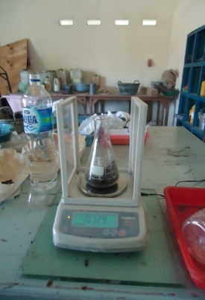
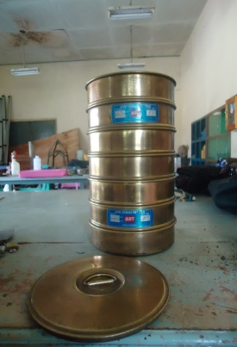
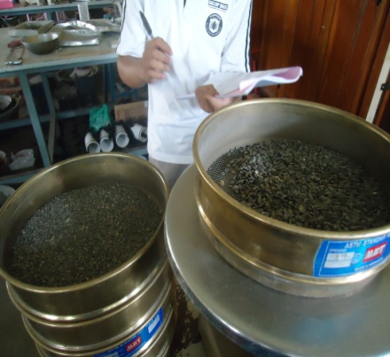
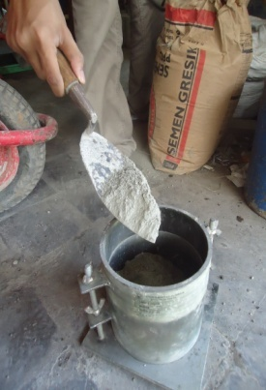

Fig.1 Material testing research activities
For the second stage is the manufacture of mix designs that consist of mixing variations of water content, mixing rock ash variations and mixing fly ash variations. In the last two mixing, each controlled the ratio of cement water and without control of water cement ratio. With the design as follows:
i. Mixed design for FAS variations (0.5, 1, 1.5, 2)
Treatment 1 Mixture: 1 Cement: 3 sand.
Treatment 2 Mixture: 1 Cement: 5 sand.
Treatment 3 Mixture: 1 Cement: 8 sand
Treatment 4 Mixture: 1 Cement: 11 sand

ii. Mixed design for stone ash variations with uncontrolled and uncontrolled Fas
Treatment 1 Mixture: 1 Cement: 0 Ash stone: 5 sand.
Treatment 2 Mixture: 1 Cement: 5% Ash stone: 5 sand.
Treatment 3 Mixture: 1 Cement: 10% Ash stone: 5 sand
Treatment 4 Mixture: 1 Cement: 15% Ash stone: 5 sand
Treatment 5 Mixture: 1 Cement: 20% Ash stone: 5 sand

iii. Mixed design for Fly Ash variations with uncontrolled and uncontrolled Fas
Treatment 1 Mixture: 1 Cement: 0 Fly Ash: 5 sand.
Treatment 2 Mixture: 1 Cement: 5% Fly Ash: 5 sand.
Treatment 3 Mixture: 1 Cement: 10% Fly Ash: 5 sand
Treatment 4 Mixture: 1 Cement: 15% Fly Ash: 5 sand
Treatment 4 Mixture : 1 Cement: 20% Fly Ash: 5 sa
The third stage of making the specimen in accordance with the Mixed design
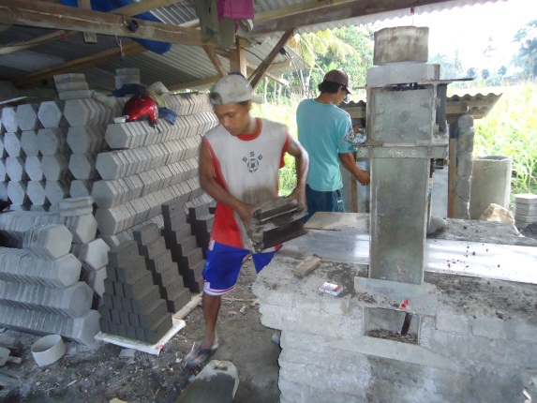
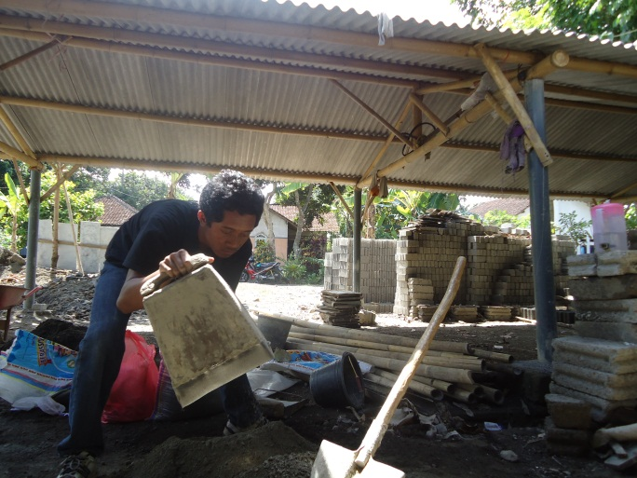
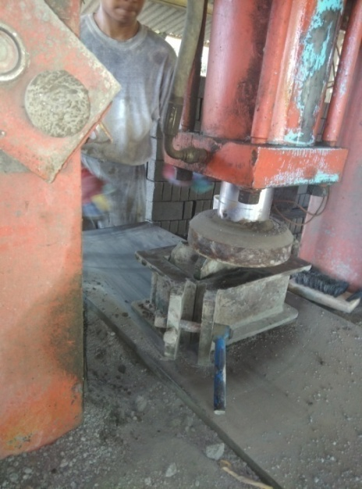

Fig 2. Activity of making specimen with pressing technology

The tool used in the process of making paving by pressing consists of several components such as the framework of the press machine as a place to press paving, electric dynamo with power 3 pk as an electric energy converter into mechanical energy, oil tank used for hydraulic pumps, for pump movement automation and equipped with a dial to measure the pressure occurring at the point of compression of the specimen. The average paving sample was pressed with an average pressure of 3 t, with the consideration that the pressure was able to make a solid paving sample without damaging the sample mold.

Fourth stage, press test
After making a sample, then done curing until the age of 28 days. The trick is to accumulate in a shady location which is then done watering every day, then ready for testing.

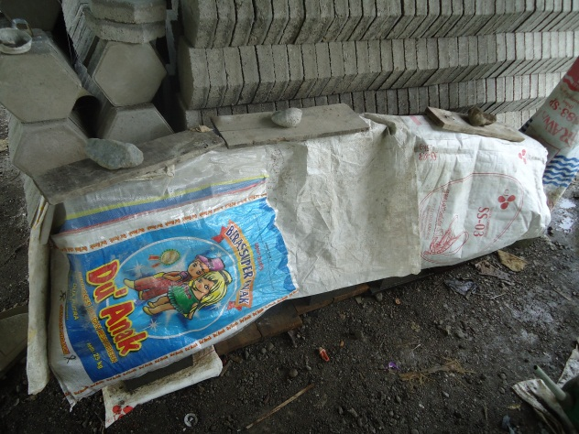
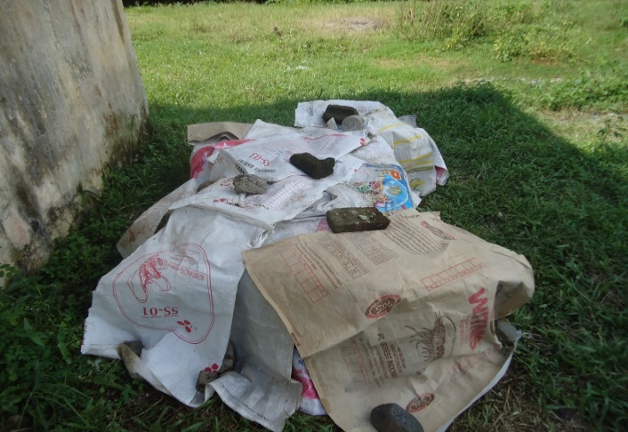

Fig. 3.Curing CPB

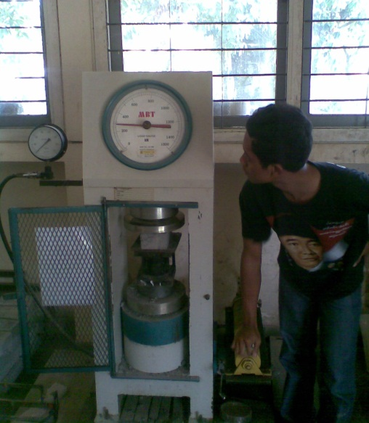

Fig. 4 Loading test
3. Results and Discussion
Prior to the manufacture of specimens, tested on paving-forming material is cement and sand which is done in the Laboratory of Structure of Faculty of Engineering, University of Jember. Test results can be seen in the following table:

Table 3.1 Data testing of sand and cement materials

Testing | Standart | Test Result | Ket.
PPC Cement
Pecific Grafity | ± 2.90 | 3.28 | ok
Unit weight
Compacted (gr/cm3) | - | 1.18
Uncompacted (gr/cm3) | - | 1.08
Fine Agregate
Sand Filter Analysis

Fine Modulus | 1.5 - 3.8 | 2.665 | ok
Zona | 1,2,3,.4 | 2
Humidity | - | 19.19%
Pecific Grafity (gr/cm3) | 2.6 | 1.88
Air Resapan | 20% | 15.85% | ok
Unit weight
Compacted (gr/cm3) | - | 1.295
Uncompacted (gr/cm3) | - | 1.091
Source: Laboratory Test Results

With the results of sieve analysis as shown below:

Fig. 5 Sieve analysis sample
With a sample size of 10 x 20 x 6 cm paving, the mixture on the FAS variation produces a compressive strength graph as shown below:

Fig. 6 Relationship of FAS Variation with CPB strength on some mix design variations

In Fig. 5 it is read that the paving device with the Press method is not capable of producing a high compressive strength and achieving only a compressive strength of less than 250 kg / cm2 despite the highest compressive strength at the lowest moisture content. This shows that the cavity in a concrete slab of CPB is still relatively high even though it is high-strengthed.
Stabilization is continued by adding a variation of filler of rock ash from 0% to 20%. For Fas of the mixed design there are two directions, corrected and uncorrected Fas. To which the corrected Fas means to maintain the condition of the crap as the filler is added, the water is added. With the equation as follows:
Addition of water due to stone crusser ash 5% =
Which :
B = Amount of water (kg / m³)
C = Total percentage of fly ash 5% to cement (kg / m³)
Ck = Moisture fly ash
Ca = Water ash fly up

In this corrected FAS it appears fig.6 that there is an upward trend along with the added stone ash filler although not significantly. The fixed pressure on the paving press indicates that compaction using only limited pressure is not able to penetrate the compressive paving strength to reach 200 kg / cm2. Thus proving that the pressing technology is not the dominant factor to get the high paving with high quality, but there are other factors that greatly affect the power of CPB. As for the FAS that is not corrected, the equation of water addition is the addition of cement water factor due to the ash of stone.
The use of water for the normal mixture =
Which:
B = Amount of water (kg / m³)
D = The amount of fine aggregate (kg / m³)
Dk = Moisture of sand
Da = Water absorption sand

Fig.7 Test results for each Fas

Further stabilization by using the addition of Fly ash filler variation from 0% to 20%. For Fas of the mixed design there are two directions, corrected and uncorrected Fas. To which the corrected Fas means to maintain the condition of the crap as the filler is added, the water is added. Figure 7 shows that the addition of fly ash filler has increased sharp compressive strength to reach 200 kg / cm2. So the use of fly ash on the machine as a filler can still be continued.

Figure 8 Filler percentage relationship with compressive strength of paving with 2-way FAS

4. Conclusion
There are some conclusions from the use of paving press for the manufacture of paving which include:
- In the range of 3 ton pressing power is only able to produce the paving presses that only achieve the strong quality of press 250 kg / cm2.
- The composition of aggregate mixture Fas that maintains a dislocation or with a controlled FAS can sustain and can raise the compressive strength of the paving otherwise unsustainable defects will decrease the compressive strength of the paving.
- The composition of each treatment mixture, starting from FAS, stone ash and Fly ash respectively can be continued again in subsequent research, due to the upward trend of compressive strength in both rock ash ash and fly ash filler.
- CPB production press machine limited use in traffic with light loads such as alley, yard and garden. And less precise for public facilities with heavy loads such as terminals, gas stations and container ports, because the resulting compressive strength does not reach the International standard. This proves that the press energy generated from the paving machine by pressing method is not able to remove water, the air is in the CPB.

Acknowledgement
This Research was conducted on funding by private industry and the Structural and Construction Laboratory of Jember University.
References

[1] “Blocks for paving — specification”, i(x 93.080.200 bis, Bureau Of Indian Standards, New Delhi 110002.
[2] G. LEESj B»Sc»j F.G.S.j A.InstoH.E, “The Design Of Aggregate Gradings To Minimum And Controlled Porosity - A Study Of Packing Characteristics And Void Characteristics In Aggregates”, Presented as a thesis for an Official Degree of the University of Birmingham, Department of Transportation October 1967*and Environmental Planning, University of Birmingham.
[3] K. Baskaran and k. Gopinath, 2013, “Study On Applicability of ACI And DOE Mix DesignMethods For Paving Blocks”, Annual Transactions of Iesl © The Institution of Engineers, , Pp. [Page Range], Sri Lanka.
[4] Mahendra Palnati, 2015,” Design, Fabrication and Analysis of A Paver Machine Push Bar Mechanism”, University of South Florida.
[5] Mohammed Seddik Meddah A,*, Salim Zitouni B, Said Belaabes B, 2010,” Effect Of Content and Particle Size Distribution Of Coarse Aggregate On The Compressive Strength Of Concrete”, Journal Homepage: Www.Elsevier.Com /Locate/Conbuildmat, Higashi-Hiroshima 739-8527, Japan.
[6] Sk SNI 15-0302-2004,” Semen Portland Pozolan”
[7] Sulistyanaa, Purwantob, Vemi Widoanindyawatib, M. Mirza Abdillah Pratamab, 2014, “The Influence of Compression Applied During Production to the Compression Strength of Dry Concrete”:2nd International Conference On Sustainable Civil Engineering Structures andConstruction Materials, , Semarang 50275, Indonesia.
[8] Tayfun Uygunoglu, Ilker Bekir Topcu, Osman Gencel, Witold Brostow, 2012, “The Effect of Fly Ash Content and Types Of Aggregates on the Properties of Pre-Fabricated Concrete Interlocking Blocks (Pcibs)”, Construction And Building Materials, Journal Homepage: Www.Elsevier.Com/ Locate/Conbuildmat.
[9] Radhikesh P. Nanda 1 , Amiya K. Das 2 , Moharana.N.C 3 “Stone crusher dust as a fine aggregate in Concrete for paving blocks” International Journal Of Civil And Structural Engineering Volume 1, No 3, 2010

[10] Arief Wahyulie, Bambang Herumanta ‘Pengaruh Faktor Air Semen (Fas) Dan Mix Design Pada Pembuatan Bata Beton (Paving Block) Terhadap Kuat Tekan” skripsi Universitas Gadjah Mada, 2014

